Our Lady of the Pillar
Confirmation Registration Form
Confirmation Date: April 27, 2024

*** Registration Requirements: In order to register your child for Confirmation you must submit, with this application, a check in the amount of $200 and a copy of the students Baptismal Certificate. All 3 must be received before your student can be registered.

Candidates for Confirmation must meet all the following criteria:
- Student of OLP day school or, PSR program, or the child of registered parishioner at OLP
- All candidates must have attended a Catholic School or PSR program during the 7th grade.

Deadline for submitting this confirmation registration is January 10, 2024. No applications will be accepted after this date!

Family Name: ____________________________________
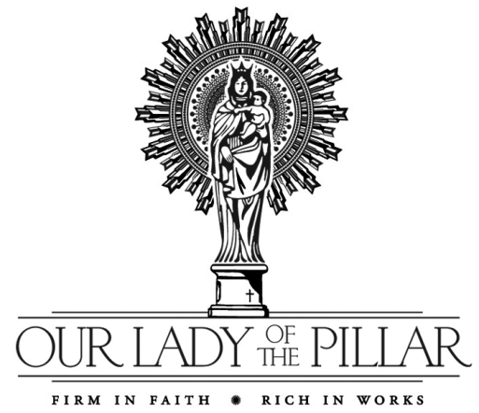

Student mailing address:____________________________

City, State, Zip:____________________________________

Home Phone: _____________________________________

Are you registered in Our Lady of the Pillar parish? YES____NO____
(Must be registered 3 months prior to filling out this registration)
If no, do not complete this form!

Parent Information
Marital Status: __________________

Dad’s Name: ____________________________ Mom’s Maiden Name: ____________________
Dad’s cell # ______________________________ Mom’s cell # ____________________________
Dad’s Email _____________________________ Mom’s Email ____________________________
Dad’s Religion ___________________________ Mom’s Religion __________________________

Please indicate what e-mail address is to be used for communications: _____________________________________

Confirmation Fee: $200

Child’s Name: ________________________________________________________________ Grade: 2023/2024_______
First Last Middle
Gender: (M/F) _____ Date of Birth: ______________________ School child attends: ____________________________

Please list all sacraments received, where they took place, and the date. (Failure to complete this section entirely will result in a delay in registration)
BAPTISM Place: __________________________________________ Date: _____________
FIRST RECONCILIATION Place: __________________________________________ Date: _____________
FIRST HOLY COMMUNION Place: __________________________________________ Date: _____________

Describe any concerns/difficulties/testing diagnoses your child has had or is currently experiencing. Please list any special concerns or problems you have about your child’s ability to interact in a school setting.
(Continued registration on reverse side)
Parent Agreement:
I agree that my student meets the above criteria for confirmation at Our Lady of the Pillar.
I agree that my student will be present for all activities and classes (the only exception being illness).

Parent Signature: __________________________________________________________

-------------------------------------------------------------------------------------------------------------------------------------------

Confirmation for Our Lady of the Pillar is April 27, 2024 at the Cathedral Basilica at 10:00 AM
Instructions from the Archdiocese concerning dress, number of guests, seating etc. will be forwarded as soon as they are available.

Confirmation Schedule:
ALL CLASSES (including mass), RETREAT AND DAY OF REFLECTION ARE MANDITORY!!!
Parent Meeting Saturday January 27, 2024 3:45-4:30 pm Church/ Basement
Saturday January 27, 2024 “Light the Fire Retreat” & Mass 1:00-6:00 pm Church/Basement
Sunday April 21, 2024 Student Day of Reflection 1:00-3:30 pm Church/Basement

CLASSES: (Classes include mass at 10:30 am)
Sunday February 4, 2024 #1 “Relationships” (Ch-6) 8:30-11:30 am Parish Office
Sunday February 11, 2024 #2 “The Bible” (Ch-5) & “The Church (Ch-9) 8:30-11:30 am Parish Office
Sunday February 18, 2024 #3 “The Jesus Question” (Ch-3) 8:30-11:30 am Parish Office
Sunday February 25, 2024 #4 “The Prayer Process” (Ch-4) & The Rosary 8:30-11:30 am Parish Office
Sunday March 3, 2024 #5 “The Eucharist” (Ch-7) 8:30-11:30 am Parish Office
Sunday April 7, 2024 #6 “The Holy Spirit” (Ch-8) 8:30-11:30 am Parish Office
Sunday April 14, 2024 #7 “Holiness is Possible” (Ch-12) 8:30-11:30 am Parish Office
& “Made For Mission” (C11)
CONFIRMATION April 27. 2024 Archbishop Mitchell Rozanski 10:00 am St. Louis Basilica

///////////////////////////////////////////////////////////////////////////////////////////////////////////////////

For office use only:
Date received: __________ Received by: ___________ Check #:__________ Amount: ______________

